## JSP Servlet and JDBC

Presentation layer : MVC model.

Business Logic layer : Handling logic.

Data access layer : communication with database.

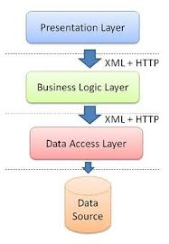

To build by jdk8 we add code in project :

<properties>

<maven.complier.source>1.8</maven.complier.source>

<maven.complier.target>1.8</maven.complier.target>

</properties>

<build>

<plugins>

<plugin>

<groupId>org.apache.maven.plugins</groupId>

<artifactId>maven-complier-plugin</artifactId>

<version>3.6.0</version>

<configuration>

<source>1.8</source>

<target>1.8</target>

</configuration>

</plugin>

</plugins>

</build>

1 : Create presentation layer.

This is MVC model includes model,view,controller.

1. Create folder WEB-INF in webapp.
   1. Create web.xml in folder WEB-INF.